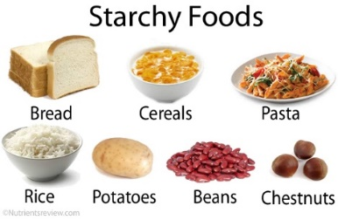
Digestion of Starch

What exactly is starch? Produced in plants by the photosynthesis of carbon dioxide, starch granules are made out of glucose polymers and serve as energy stores. Towards the end of the growing season, starch accumulates in twigs of trees, close to the buds. It is also found in fruits, seeds, rhizomes and tubers.
© Nutrientsreview.com
When required, starch is broken down into its constituent monomer glucose units. This happens with the help of certain enzymes and water. The glucose units can then diffuse from the cell to nourish the plant tissues.

Material: 3 beakers, 2 pipettes, glucose test strips (indicator)
Chemicals: starch solution, potassium iodide solution, diluted hydrogen chloride (HCl), saliva
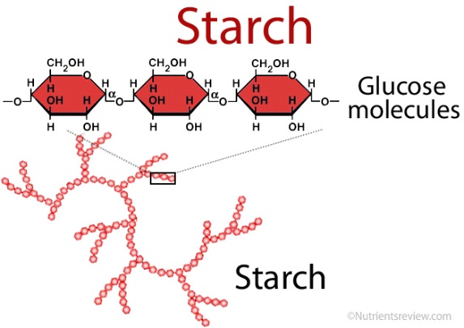
Conduction:
- Fill 30 ml of starch solution into every beaker (1, 2, 3)
- Add to beaker 1: nothing
beaker 2: a few ml saliva
beaker 3: 1 ml HCl and a few ml saliva
- With potassium iodide solution, test all three samples for starch
- Test all three samples with a glucose test strip
© Nutrientsreview.com

Observation: Note down your observations in the table.

 | Beaker 1  (starch solution only) | Beaker 2  (starch solution + saliva) | Beaker 3  (starch solution +  saliva + HCl)
Test for starch
Test for glucose

starch – Stärke
(to) accumulate – sich ansammeln
twig – Zweig
rhizome – Wurzelstamm
tuber – Knolle
constituent – Bestandteil
glucose units – Zuckereinheit /-baustein
(to) nourish – versorgen, ernähren

beaker – Becherglas
potassium iodide solution – Kaliumiodid-Lösung
saliva - Speichel

Results: Try to explain your observations.
Beaker 1
Beaker 2
Beaker 3

