Introduction to enzymes: Enzymes are biocatalysts
A chemical reaction comprises breaking and forming bonds within chemical compounds. In order to restructure or divide a reactant to create a product, some bonds have to be removed and others have to be formed. For a chemical reaction to take place, an energy barrier has to be overcome. The so-called activation energy, which denotes the energy needed to break up a bond, can be provided by thermal energy (i.e. heat). Absorbing energy causes bonds between certain molecules to become unstable and ultimately makes them collapse. The reaction ends when new bonds form and the actual products emerge. It should also be noted that energy is given off when the bonds of the resulting chemical compounds form. Yet, due to the temperatures within a cell most chemical reactions can only take place very slowly or not at all.

The situation in a cell
Metabolic processes in the human body are no exception when it comes to the basic principles for chemical reactions. However, providing the activation energy with heat proves to be quite problematic for a cell. Subjecting cells to excessive heat would not only damage or even kill the cells, but many different reactions would be triggered at the same time. Adding heat to certain areas of the cell would also be quite difficult because of the small dimensions we are looking at. The solution to this problem are enzymes which control the chemical reactions within the cells. Enzymes are highly specific biocatalysts that enable the chemical reactions of our metabolism to take place at much lower temperatures.

Effects of catalysts – Why biocatalysts (enzymes) are different from chemical catalysts
Catalysts accelerate the reaction rates by lowering the activation energy (see Fig. 1). Although they take part in the reaction, they are not consumed or changed in the process. Compared to chemical catalysts like manganese dioxide, platinum and nickel, enzymes are more precise in their effects as they very often catalyse only one reaction. In science, this characteristic is referred to as their reaction specificity. Moreover, biocatalysts can be regulated by other systems and usually accelerate reactions much faster than chemical catalysts.

(to) comprise – beinhalten
compound – Verbindung
reactant – Reaktionspartner

activation energy – Aktivierungsenergie
(to) denote – bezeichnen
thermal – thermisch (Wärme)
(to) cause – bewirken

(to) emerge – entstehen, auftauchen
due to – wegen

metabolic processes – Stoffwechselvorgänge
exception – Ausnahme

biocatalyst – Biokatalysator, Bed. Beschleuniger von chem. Reaktionen

(to) accelerate – beschleunigen
(to) lower – erniedrigen, senken
(to) take part – teilnehmen
(to) consume – verbrauchen

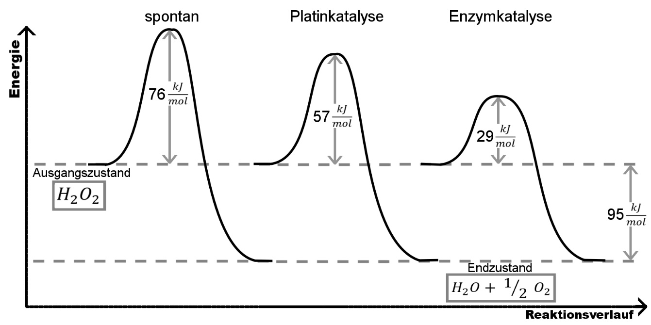
Figure 1: Activation energy in a reaction without and with a catalyst in the example of breaking down hydrogen peroxide [H₂O₂].

An enzyme-induced reaction
How enzymes manage to lower the activation energy and how the very reaction takes place is based on a few key principles. Enzymes are proteins with catalytic properties. However, not the entire enzyme takes part in the reaction, but only the so-called active centre. The active centre could best be described as a cavity or pouch that is embedded in the structure of enzymes. In most cases the active centre only fits for one type of substrate like one key only fits into one type of lock. This lock and key model explains what biologists mean when they talk about an enzyme’s substrate specificity. During an enzyme-induced reaction, the substrate forms a bond with the active centre. When substrate and enzyme are bound together, they temporarily form a so-called enzyme substrate complex. Within this structure, the bonds between certain atoms of the substrate are distorted, stretched or influenced by physical interactions. This process ultimately causes the bonds to become unstable which lowers the energy level needed for them to break apart (see Fig. 2).

key principle – Schlüsselprinzip
property – Eigenschaft
active centre – aktives Zentrum
cavity – Hohlraum
pouch – Beutel
(to) be embedded in – in etw. eingebettet sein
substrate – Substrat
key – Schlüssel
lock – Schloss
(to) induce – veranlassen, hervorrufen
(to) distort – verformen

unstable – unstabil

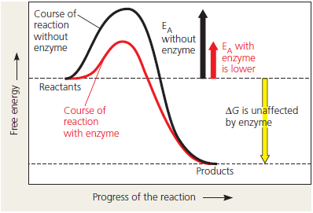

Figure 2: The effects of an enzyme on energy levels (Source: Campbell & Reece, 2011, p.153).

Hence, bonds can be broken because the thermal energy (i.e. heat) within the cell is enough to initiate the reaction. New bonds are then formed between other atoms. As the final products emerge the reaction is completed.
Although the enzyme-substrate complex disintegrates while the product is formed, the enzyme itself remains unchanged, which makes it available for another reaction with a substrate molecule.

Tasks:
- Enzymes are biocatalysts. Try to explain how an enzyme works and include figure 2 into your thoughts/text.
- Describe the concepts behind the terms substrate specificity and reaction specificity.
- Try to outline the procedure of an enzyme induced reaction with a verbal equation while using the following symbols:
S = Substrate ; P = Product ; E = Enzyme ; [ES] = Enzyme-Substrate complex
- Graphically illustrate the procedure of an enzyme induced reaction in a labelled schematic map.

(to) disintegrate – zerfallen
(to) remain – verbleiben

