Enzymes do not just split substrate!
Apart from breaking up substrates, enzymes can also effect molecules in other ways. Task: With the information given in the table, describe the reaction in the last column.
Tool | Reaction schema | Enzyme group | Catalysed reaction
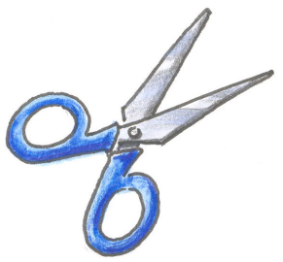  Scissors | 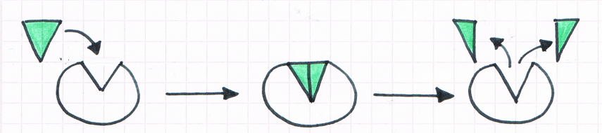 | Lyases
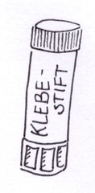  Glue | 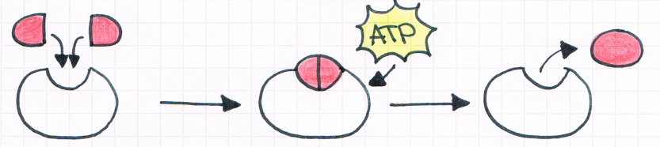 | Ligases
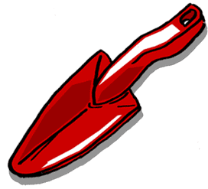  Shovel | 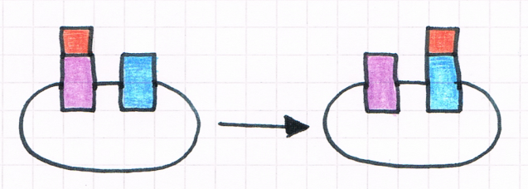 | Transferases
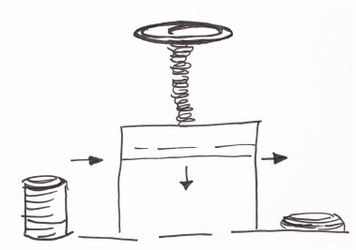  Press | 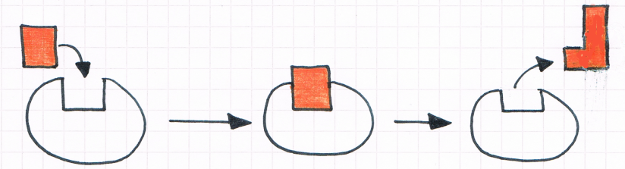 | Isomerases
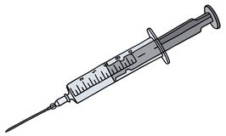 Syringe | 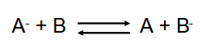 | Oxidoreductases

