|  |  |
| --- | --- |
|  | 1. Read the text “Characteristics of native amphibians”. Note down the main ideas of each paragraph in your own words (left column of the table). Find suitable key words (right column). |
|  | 1. In your group, cover the text of the left column and summarize the most important information. Try to use your key words only. |

Characteristics of native amphibians

Amphibians can live on land or in water. There are two basic groups of amphibians: Anura (***toads*** and frogs, fig. 1 1-2) and Caudata (salamanders and ***newts***, fig.1 3-4). While ***adult*** Caudata show a tail, Anura do not have one as adults.

Some key characteristics of our amphibians:

* ***Moist, permeable* skin**: The skin of amphibians is a highly specialized organ that plays an important role in ***respiration***. Amphibians basically breathe through their skin (most adult amphibians also breathe through lungs). Amphibians have moist skin. The skin usually has ***glands*** which produce a slimy substance called ***mucus***. Mucus glands prevents the skin from drying out. Some even have poison glands in the skin. This helps protect them from being eaten by other animals.
* **Life cycle**: The life cycle consists of two phases: The ***larvae*** and the adult form. Most amphibians lay eggs in the water. The larvae ***hatches*** and lives in the water. The ***transformation*** from an ***aquatic*** larvae to a ***terrestrial animal*** is called metamorphosis. As adults, amphibians usually live on land.
* ***Reproduction* in water**: Amphibians mostly lay a large number of eggs in aquatic ***habitats***. Often males are smaller than females (fig. 1).
* **Regulation of body temperature**: Amphibians are cold-blooded. This means the body temperature of an amphibian is always about the same as the temperature of their environment. If their surroundings get too cold or too hot, amphibians move to another place. For example, if the sun is too hot, they move into the shade.
* ***Hibernation***: In winter amphibians can become very inactive and enter a state of hibernation. During this resting state, they stay at the bottom of ponds, where they breathe through the skin. Others like to hide in holes or under leaves. They become active again in spring when it gets warmer.

Amphibians play a crucial role in ecosystems, i.e. by controlling insect populations and serving as food for other animals, like birds, snakes and snails. But many species are currently threatened by habitat destruction, ***pollution***, and climate change. This makes conservation efforts important.

Some of the most common amphibians found in our surroundings include:

1. Common toads (*Bufo bufo*) live in shaded forests, parks and gardens. Female carries male toad.

2. Common frogs (*Rana temporaria*) live close to or in ponds in grasslands. Female carries male frog.

3. Salamanders (*Salamandra salamandra*) live in forests with slow flowing ***creeks***.

4. Smooth newts (*Lissotriton vulgaris*) live in ponds with many plants. Male (left) and female (right).

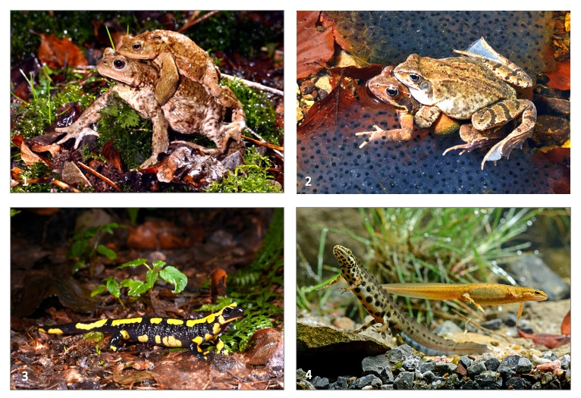Figure 1 Common toads (1), Common frogs (2), Salamander (3), Smooth newts (4) Pictures: © Benny Trapp

Vocabulary: Characteristics of native amphibians

|  |  |
| --- | --- |
| Englisch | Deutsch |
| *toad* | die Kröte |
| *newt* | der Wassermolch |
| *adult (Adj.)* | erwachsen/reif |
| *adult* | der Erwachsene |
| *moist (Adj.)* | feucht |
| *permeable (Adj.)* | durchlässig |
| *respiration* | die Atmung |
| *gland* | die Drüse |
| *mucus* | der Schleim |
| *larvae* | die Larve |
| *(to) hatch* | schlüpfen |
| *transformation* | die Umwandlung |
| *aquatic (Adj.)* | wasserlebend |
| *terrestrial animal* | das Landtier |
| *reproduction* | die Fortpflanzung |
| *habitat* | das Habitat/ der Lebensraum |
| *hibernation* | die Überwinterung/ der Ruhezustand |
| *pollution* | die Umweltverschmutzung |
| *creek* | der Bach |

|  |  |
| --- | --- |
| Main ideas (your own words) | Key words |
|  |  |