Metamorphosis - From Tadpole to Adult Frog

**Metamorphosis**

Like butterflies, frogs undergo an impressive transformation which is called ***metamorphosis***.

**1. Egg Stage**

Frogs lay hundreds of jelly-like eggs in water (***frog-spawn***) which look like round cluster.

**4. Early Metamorphosis**

Back leg begin to form and a log tail develops. Lungs develop internally.

**2. Early larvae stage**

The develop into embryos, still in a jelly-like substance and then hatch into free-swimming ***tadpoles***.

**5. Late Metamorphosis**

Front legs begin to form and the tadpole´s gills are covered by skin as lungs become fully functional. The tail begins to ***shrinks***.

**3. Tadpole Stage**

Tadpoles have ***gills*** for underwater respiration, but lack ***limbs***. The stay close to water plants and feed on algae and plant material. They have a long tail, which they need for swimming.

**6. Adult frog stage**

The frog loses its tail entirely. It begins using its lung for respiration and is therefore able to live on land.

Vocabulary

|  |  |
| --- | --- |
| Englisch | Deutsch |
| *frog spawn* | der Froschlaich |
| *metamorphosis* | Metamorphose, Gestaltumwandlung |
| *tadepole* | die Kaulquappe |
| *gills (Pl.)* | die Kiemen (meist im Pl.) |
| *limb* | das Körperglied |
| *(to) shrink* | schrumpfen |

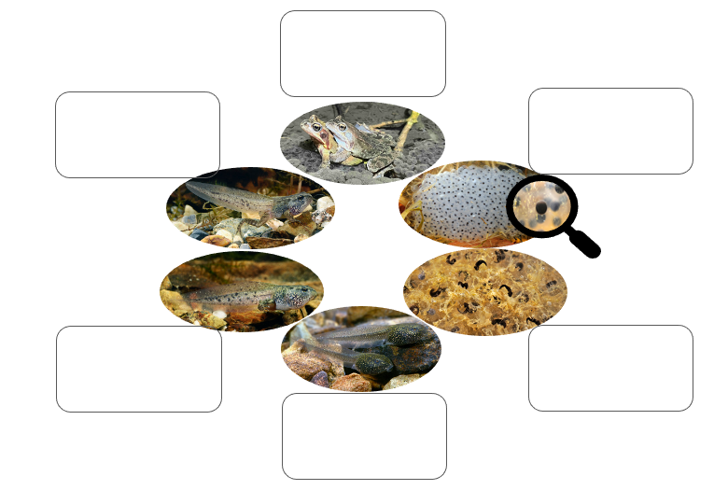**Aufgabe: Beschreibe mit Deinen eigenen Worten in den Kästchen neben den Bildern, wie die Entwicklung vom Ei zum Frosch abläuft.**

Fotos: © Benny Trapp & Sabrina Bleidißel