Merkmale der in Deutschland heimischen Anura; Characteristics of the Anura native to Germany
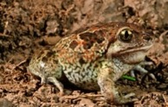
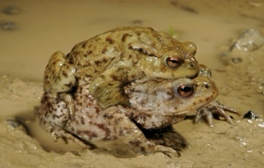
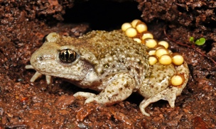
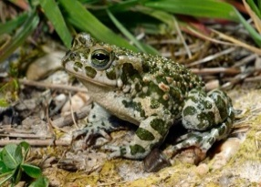
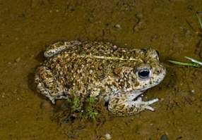
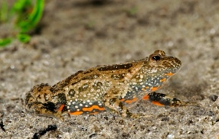
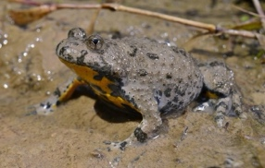
common name | Knoblauchkröte  Garlic toad | Erdkröte  Common toad | Geburtshelfer-kröte  Common Midwife toad | Wechselkröte  Green toad | Kreuzkröte  Natterjack toad | Gelbbauchunke  Yellow-bellied toad | Rotbauchunke  Fire-bellied toad
scientific name | Pelobates fuscus | Bufo bufo | Alytes obstetricans | Bufotes viridis | Epidalea calamita | Bombina variegata | Bombina bombina
pupil | vertical | horizontal | vertical | horizontal | horizontal | heart-shaped | heart-shaped
skin | smooth | rough, „warty“ | rough, „warty“ | rough, „warty“ | rough, „warty“ | rough, „warty“ | rough, „warty“
Basic color | light-grey to beige-brown | reddish brown to grayish brown | grey, olive or brown | beige to greenish | olive, brown or grey | dark-grayish to gray or brown | dark-grayish to gray or brown (sometimes greenish)
color of belly | white with grey mottling | light with dark marbling and spots | pale grey to whitish, partly covered with cream dots and spots | white or beige, sometimes with black spots | light with dark marbling | some yellow pattern on a black-grey background | many red/orange pattern on a black-grey background with white dots
spots (size) | large brown, often mergeing | black, at least dark dots - partly merging | small greenish or brown | Pattern of green to olive-colored, sharply defined spots | irregular fusing pattern | dark, smaller spots. May also be missing | Mostly olive, larger patches, round or elongated
species-specific features | hardened protrusions on hind feet,  smell of garlic when stressed | warty skin, prominent parotoids | two rows of large warts (often reddish) on both sides of the back, Male carrying eggs | striking camouflage pattern | yellow line down the middle of the back | toad reflex when threatened | toad reflex when threatened
required habitat | open landscapes whith sandy soils | woodland, grassland and gardens, not picky | steppe-like, open habitats | steppe-like, habitats | steppe-like, habitats | bushlands, meadows, floodplains with ponds, riverbanks | bushlands, meadows, floodplains with ponds  © Fotos Benny Trapp

Merkmale der in Deutschland heimischen Anura; Characteristics of the Anura native to Germany
 |  | Brown frogs - Braunfrösche |  |  | Green frogs - Grünfrösche
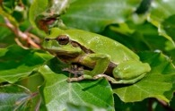
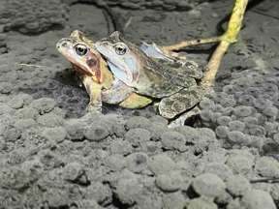
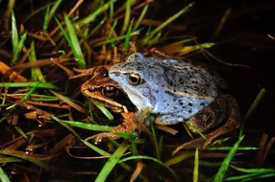
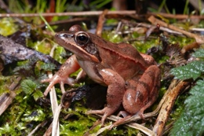
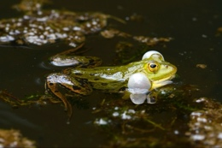
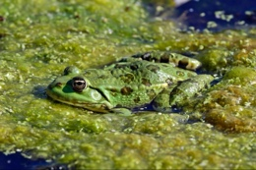
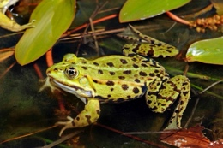
common name | Laubfrosch  Tree frog | Grasfrosch* Common grass frog | Moorfrosch* Moor frog | Springfrosch* Agile frog | Kleiner Wasserfrosch** Pool frog | Seefrosch**  Marsh frog | Teichfrosch** Edible frog
scientific name | Hyla arborea | Rana temporaria | Rana arvalis | Rana dalmatina | Pelophylax lessonae | Pelophylax ridibundus | Pelophylax esculentus
pupil | horizontal | horizontal | horizontal | horizontal | horizontal | horizontal | horizontal
skin | smooth | smooth | smooth | smooth | smooth | smooth | smooth
Basic color | green to light-grey, | grey, brown, olive, yellowish, reddish | grey, light-olive, brown, yellowish or rufous | yellowish, brown, greyish or rufous | green, yellowish-green, olive-green or greyish-green | tints of greyish and green, from grey to green | greyish-green, olive-green or green
color of belly | white | male: white to yellow  female: dark, yellow-reddish pattern | white or yellowish | white or white-pink, without pattern | white or yellowish-white | greyish-white/ yellow with dark spotted pattern | light, usually with dark spots
spots (size) | dark, uninterrupted band | dark, irregular, very variable | dark, irregular, very variable | few dark spots, V-shaped spot behind head | different number and size, dark | large dark | different number and size, dark
species-specific features | coloration depending on substrate;  toes expanded into discs | tends to jump not walk | male during the breeding season, light-blue coloration of the body | tends to jump not walk | two white vocal sacs at head ends | two dark vocal sacs at head ends | two dark white vocal sacs at head ends
required habitat | diversely structured landscapes | woodland, grassland and gardens | moorland, wet meadows, marsh, floodplain, | woodland, grassland with ponds | ponds, pools | ponds, slowly flowing rivers  © Fotos Benny Trapp, Sabrina Bleidißel (Grasfrosch) | ponds, pools rarely at slowly flowing rivers
* Mitteleuropäische Arten die u.a. unter der Gruppe Braunfrösche zusammengefasst werden
** Oberbegriff Grünfrösche, wobei kleiner Wasserfrosch und Seefrosch eigene Arten darstellen und der Teichfrosch eine Mischform aus den beiden erstgenannten Arten ist und keinen echten Artstatus besitzt.

